**APEX COLLEGE**

**POKHARA UNIVERSITY**

**LAB REPORT OF**

**DOT NEW TECHNOLOGY**

**LAB-8**

**Submitted By:                                               Submitted To:**

**Ruchi Agrawal                                               Bishwomitra Adhikari**

**BCIS ‘Adware’** **Ananta Pant**

**Roll no: 18**

**Objectives: To perform the detailed verification in Postman**

*Navigate to “Startup.cs” and add entries for RepositoryModule and ServiceModule in the method ConfigureServices as below.

**RepositoryModule.cs**

using Microsoft.EntityFrameworkCore;

using Microsoft.Extensions.DependencyInjection;

using ApexRestaurant.Repository.RCustomer;

using ApexRestaurant.Repository.RMeal;

using ApexRestaurant.Repository.RMeal_Dish;

using ApexRestaurant.Repository.RStaff;

using ApexRestaurant.Repository.RMenu;

using ApexRestaurant.Repository.RMenu_Item;

using ApexRestaurant.Repository.RRef_Staff_Role;

namespace ApexRestaurant.Repository

{

    public static class RepositoryModule

    {

        public static void Register(IServiceCollection services, string connection, string migrationsAssembly)

            {

                services.AddDbContext<RestaurantContext>(options => options.UseSqlServer(connection, builder => builder.MigrationsAssembly(migrationsAssembly)));

                 services.AddTransient<ICustomerRepository,CustomerRepository>();

                services.AddTransient<IMenu_ItemRepository,Menu_ItemRepository>();

                services.AddTransient<IMenuRepository,MenuRepository>();

                services.AddTransient<IRef_Staff_RoleRepository,Ref_Staff_RoleRepository>();

                services.AddTransient<IMeal_DishRepository,Meal_DishRepository>();

                 services.AddTransient<IMealRepository,MealRepository>();

                services.AddTransient<IStaffRepository,StaffRepository>();

            }

    }

}

Under “Controllers” folder, add “CustomerController.cs”

using ApexRestaurant.Repository.Domain;

 using ApexRestaurant.Services.SCustomer;

 using Microsoft.AspNetCore.Mvc;

namespace ApexRestaurant.Api.Controller

 {

     [Route("api/customer")]

      public class CustomerController : ControllerBase

      {

        private readonly ICustomerService _customerService;

        public CustomerController(ICustomerService customerService)

         {

             _customerService = customerService;

         }

         [HttpGet] [Route("{id}")]

          public IActionResult Get([FromRoute] int id)

         {

             var customer = _customerService.GetById(id);

             if (customer == null) return NotFound();

             return Ok(customer);

         }

            [HttpGet] [Route("")] public IActionResult GetAll()

            {

                var customers = _customerService.GetAll();

                return Ok(customers);

             }

            [HttpPost]

            [Route("")]

             public IActionResult Post([FromBody] Customer model)

              {

                   _customerService.Insert(model);

            return Ok();

}

            [HttpPut]

             [Route("")]

             public IActionResult Put([FromBody] Customer model)

             {

                  _customerService.Update(model);

                 return Ok();

              }

              [HttpDelete]

              [Route("")]

               public IActionResult Delete([FromBody] Customer model)

                {

                    _customerService.Delete(model);

                     return Ok(); }

                }

}

Navigate to http://localhost:5000/api/customer/ in your browser for verification.

Perform the following in Postman for detailed verification.

<https://localhost:5001/api/customer>

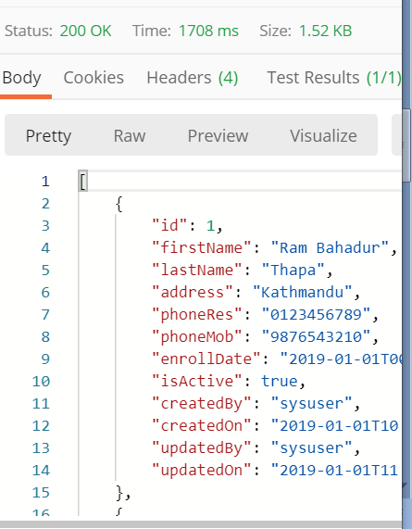

Output:

[{"id":1,"firstName":"Ram Bahadur","lastName":"Thapa","address":"Kathmandu","phoneRes":"0123456789","phoneMob":"9876543210","enrollDate":"2019-01-01T00:00:00","isActive":true,"createdBy":"sysuser","createdOn":"2019-01-01T10:00:00","updatedBy":"sysuser","updatedOn":"2019-01-01T11:00:00"},{"id":2,"firstName":"sita ","lastName":"lama","address":"china","phoneRes":"0123456789","phoneMob":"9876543210","enrollDate":"2019-01-01T00:00:00","isActive":true,"createdBy":"sysuser","createdOn":"2019-01-01T10:00:00","updatedBy":"sysuser","updatedOn":"2019-01-01T11:00:00"},{"id":3,"firstName":"sita ","lastName":"lama","address":"china","phoneRes":"0123456789","phoneMob":"9876543210","enrollDate":"2019-01-01T00:00:00","isActive":true,"createdBy":"sysuser","createdOn":"2019-01-01T10:00:00","updatedBy":"sysuser","updatedOn":"2019-01-01T11:00:00"},{"id":4,"firstName":"ritu ","lastName":"adhikari","address":"chilly","phoneRes":"0123456789","phoneMob":"9876543210","enrollDate":"2019-01-01T00:00:00","isActive":true,"createdBy":"sysuser","createdOn":"2019-01-01T10:00:00","updatedBy":"sysuser","updatedOn":"2019-01-01T11:00:00"},{"id":5,"firstName":"ritu ","lastName":"adhikari","address":"chilly","phoneRes":"0123456789","phoneMob":"9876543210","enrollDate":"2019-01-01T00:00:00","isActive":true,"createdBy":"sysuser","createdOn":"2019-01-01T10:00:00","updatedBy":"sysuser","updatedOn":"2019-01-01T11:00:00"}

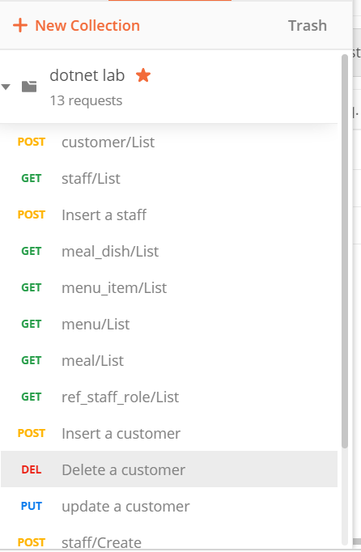

**Conclusion**

In this lab, we learned and perform the detailed verificationin Postman